CERTIFICATE

This is to certify that the mini project report entitled

M. S. DHONI

By

**Ashish S. There (47) Prajwal D. Mahajan (31)**

**Jay A. Wankhade (53)**

In the partial fulfilment of the required for the degree of **BE- 2nd year** in **Computer Science And Engineering**. During academic year **2019-2020** under my guidance.

Prof. P. D. Thakar Dr. P. A. Khodke

Guide HOD

Computer Science & Engineering Computer Science & Engineering

Prof. Ram Meghe College of Engineering Prof. Ram Meghe College of Engineering

& Management, Badnera & Management, Badnera



**Department of CSE**

**Prof. Ram Meghe College of Engineering & Management, Badnera**

**Sant Gadge Baba Amravati University, Amravati**

**2019-2020**

**Mini Project Report**

**On**

M. S. DHONI

**Submitted By**

**Ashish S. There (47) Prajwal D. Mahajan (31)**

**Jay A. Wankhade (53)**

**Under The Guidance of**

**Prof. P. D. Thakar**



**Department of CSE**

**Prof. Ram Meghe College of Engineering & Management, Badnera**

**Sant Gadge Baba Amravati University, Amravati**

**2019-2020**

**I N D E X**

|  |  |  |
| --- | --- | --- |
| SR. NO | CONTENTS | PAGE NO. |
| 01. | INTRODUCTION | 04 |
| 02. | DEVELOPMENT TOOLS | 04 |
| 03. | FEATURES | 04 |
| 04. | SNAPSHOTS | 05 |
| 05. | SOURCE CODE | 08 |

01.INTRODUCTION

A mini project name as “M.S Dhoni” is based on the use of HTML & CSS. This project contains the information about career of M.S Dhoni. It also contains the biography of M.S Dhoni.

02.DEVELOPMENT TOOLS

We make our module with HTML & CSS

* Languag: HTML & CSS.
* We used NOTEPAD as our text editor.
* Web-Browser: Google Chrome/Mozilla Firefox

03.FEATURES

* Inexpensive
* User Friendly
* Fully Informative

04.SNAPSHOTS

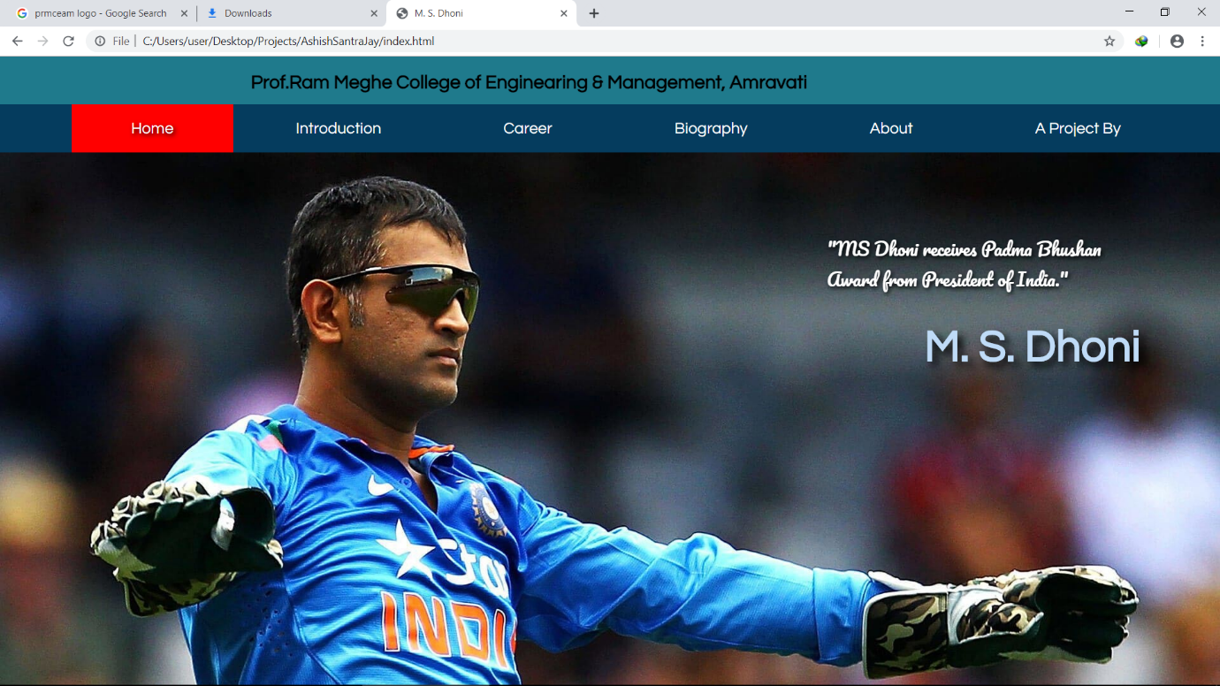

Fig 1. Home Page

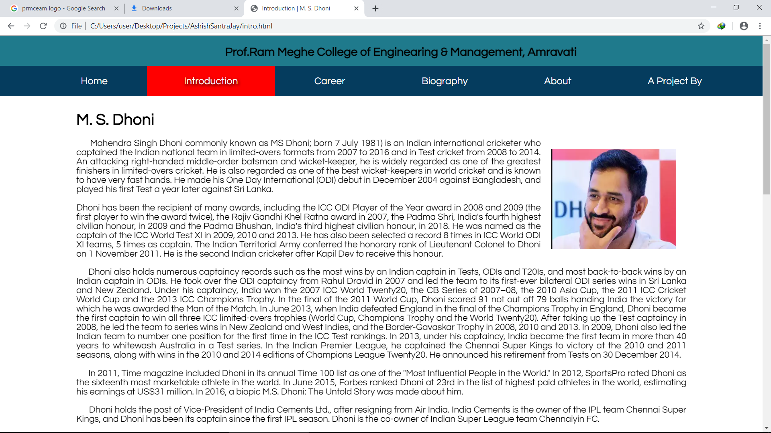Fig 2. Introduction Page

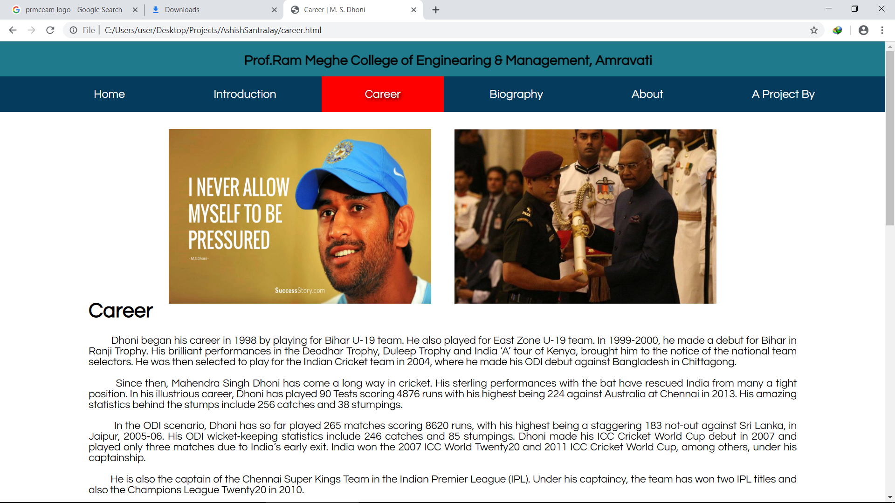

Fig 3. Career Page

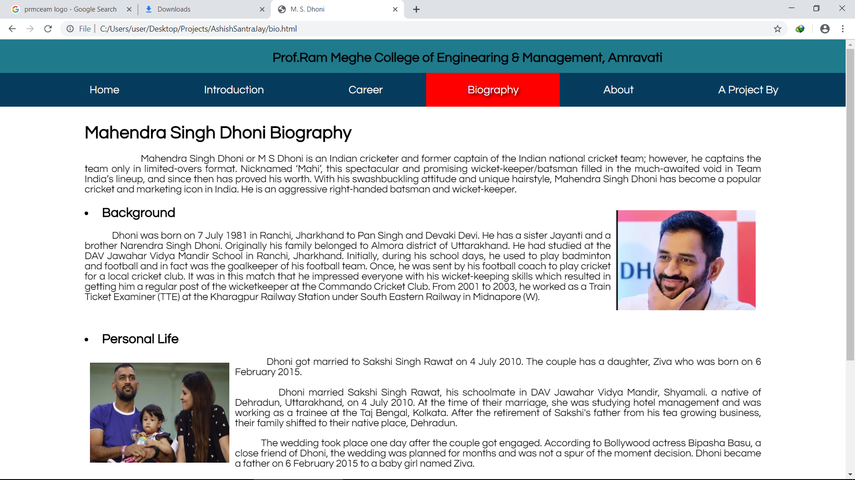

Fig 4. Biography Page

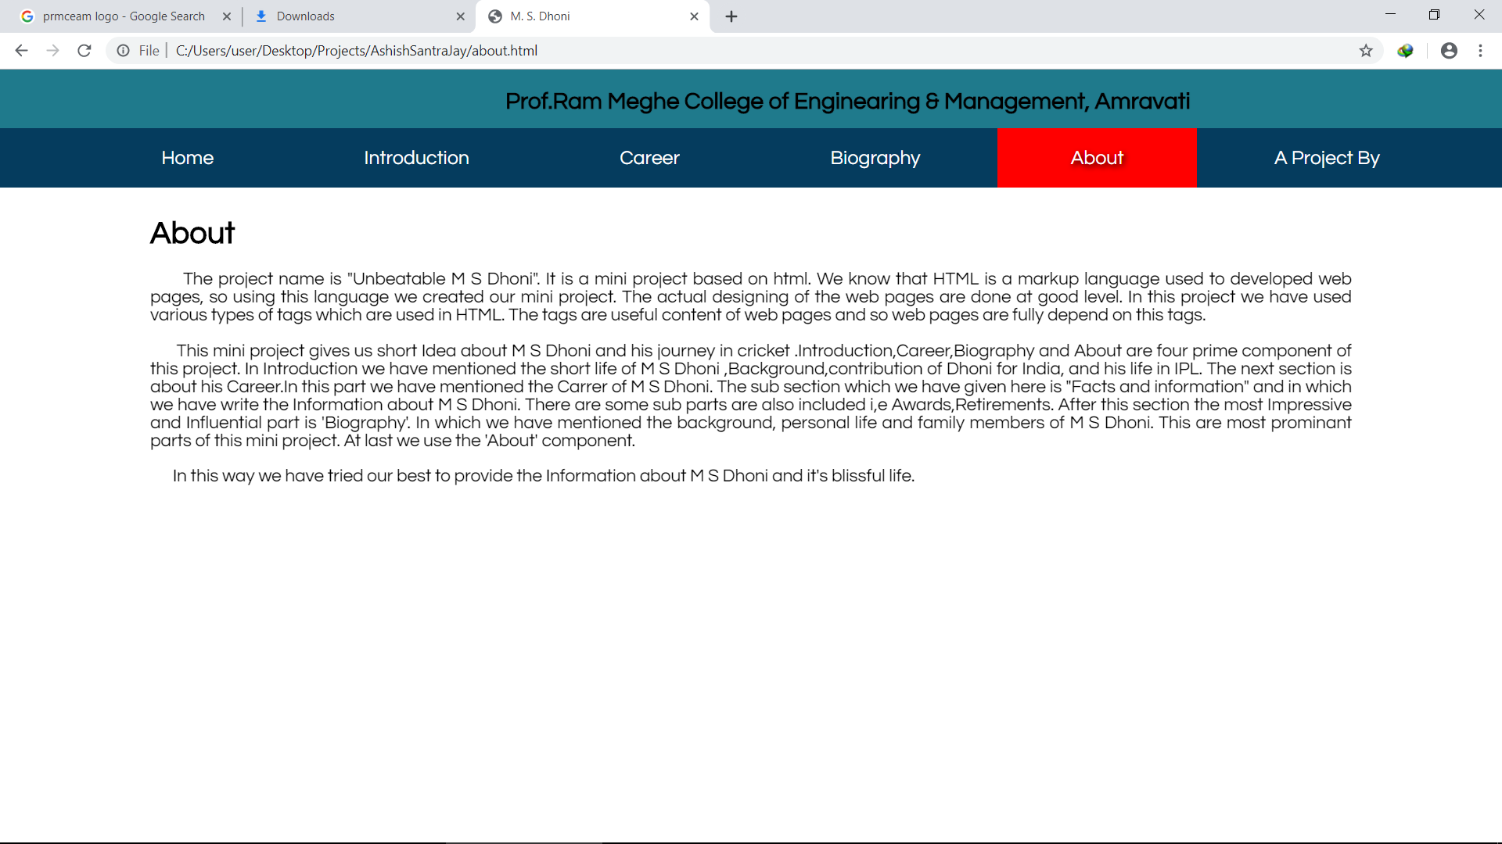

Fig3. About Page

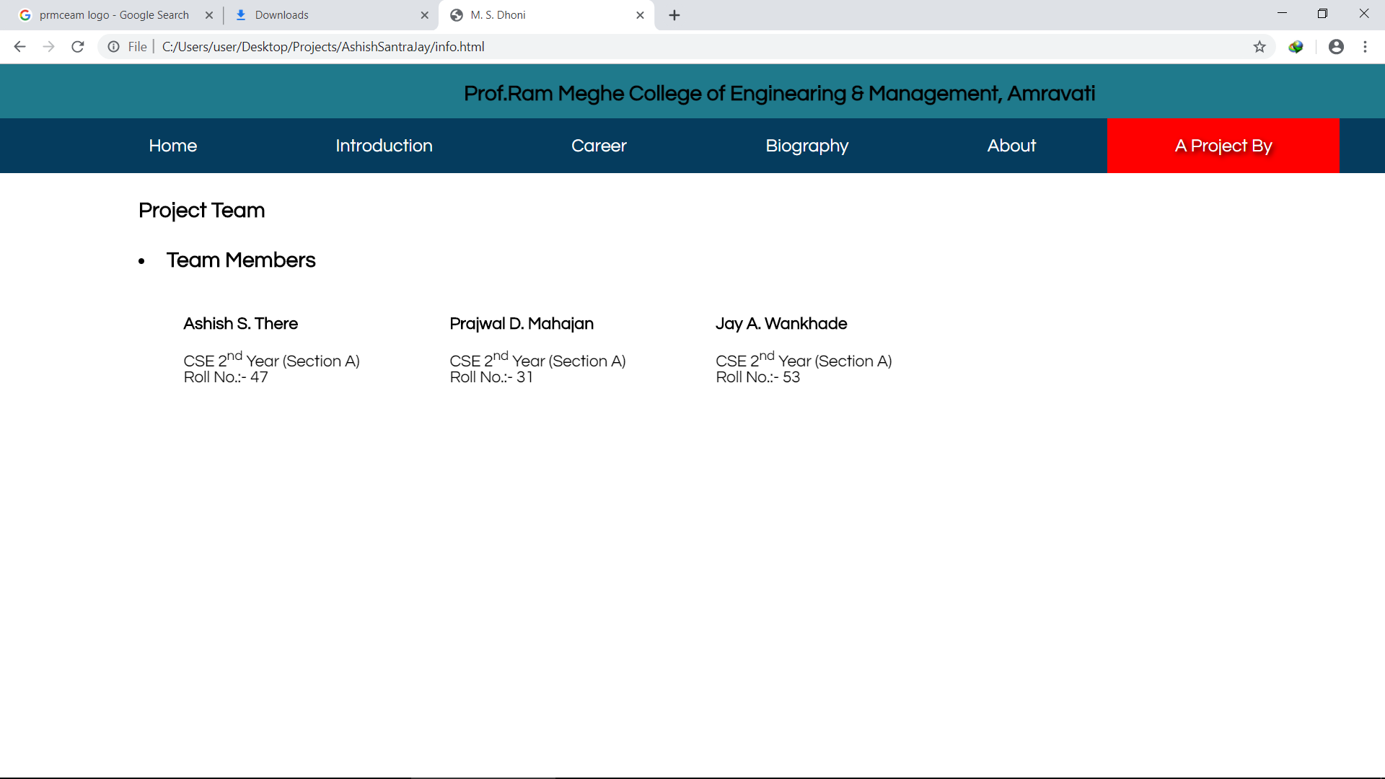

Fig 6. A Product By Page

05.SOURCE CODE

style.css

body{

width: 100%;

height: 100%;

margin: 0;

padding: 0;

font-family: 'Questrial', sans-serif;

}

p{

text-align: justify;

font-size: 18px;

}

#navigation ul{

list-style: none;

text-align: center;

font-size: 20px;

}

.name{

padding: 10px 50px 10px 50px;

style.css

float: left;

}

#navigation li{

display: inline;

padding: 20px 5% 20px 5%;

}

.container{

width: 80%;

margin: 0 auto;

}

.current{

background: red;

font-style: bold;

text-shadow: 2px 2px 6px #000;

}

#navigation{

width: 100%;

position: absolute;

top: 60px;

style.css

left: 0;

background: #053C5E;

color: #fff;

}

#head{

position: absolute;

top: 0;

left: 0;

width: 100%;

height: 60px;

background: #1F7A8C;

}

#head h2{

padding:0;

float: left;

}

#navigation a{

text-decoration: none;

color: #fff;

}

style.css

#text h1{

color: #BFDBF7;

position: absolute;

top: 300px;

right: 100px;

font-size: 3.5em;

text-shadow: 6px 6px 10px #000;

}

#text p{

color: #fff;

font-family: 'Pacifico', cursive;

position: absolute;

top: 200px;

right: 150px;

font-size: 22px;

text-shadow: 2px 2px 6px #000;

}

#navigation li:hover{

cursor: pointer;

background: red;

text-shadow: 2px 2px 6px #000;

style.css

}

#para{

position: relative;

top: 130px;

margin-bottom: 20px;

}

#career{

font-size: 18px;

}

#bio{

position: relative;

top: 130px;

margin-bottom: 20px;

}

#about{

position: relative;

top: 130px;

}

style.css

#para{

position: relative;

top: 130px;

}

#for-bg img{

position: fixed;

width: 100%;

top: 120px;

}

#details{

position: relative;

top: 130px;

}

#details h2{

padding-top: 10px;

}

#career img{

text-align: center;

style.css

position: relative;

top: 130px;

margin: 0 auto;

padding: 20px;

}

#members img{

float: left;

}

#members table{

float: left;

padding: 40px;

font-size: 18px;

}

index.html

<!DOCTYPE html>

<html>

<head>

<title>M. S. Dhoni</title>

<link rel="stylesheet" type="text/css" href="style.css">

<link href="https://fonts.googleapis.com/css?family=Pacifico|Questrial" rel="stylesheet">

</head>

<body>

<header id="head">

<marquee><h2>Prof.Ram Meghe College of Enginearing & Management, Amravati&nbsp;&nbsp; &nbsp; &nbsp; &nbsp; &nbsp; &nbsp; &nbsp; &nbsp; &nbsp; &nbsp; &nbsp;&nbsp;&nbsp; &nbsp; &nbsp; &nbsp; &nbsp; &nbsp; &nbsp; &nbsp; &nbsp; &nbsp; &nbsp;&nbsp;&nbsp; &nbsp; &nbsp; &nbsp; &nbsp; &nbsp; &nbsp; &nbsp; &nbsp; &nbsp; &nbsp;&nbsp;&nbsp; &nbsp; &nbsp; &nbsp; &nbsp; &nbsp; &nbsp; &nbsp; &nbsp; &nbsp; &nbsp;&nbsp;&nbsp; &nbsp; &nbsp; &nbsp; &nbsp; &nbsp; &nbsp; &nbsp; &nbsp; &nbsp; &nbsp;&nbsp;&nbsp; &nbsp; &nbsp; &nbsp; &nbsp; &nbsp; &nbsp; &nbsp; &nbsp; &nbsp; &nbsp; Mini Project : M. S. Dhoni</h2></marquee>

index.html

</header>

<div id="for-bg">

<img src="dhoni.jpg">

</div>

<nav id="navigation">

<ul>

<a href="index.html"><li class="current">Home</li></a>

<a href="intro.html"><li>Introduction</li></a>

<a href="career.html"><li>Career</li></a>

<a href="bio.html"><li>Biography</li></a>

<a href="about.html"><li>About</li></a>

<a href="info.html"><li>A Project By</li></a>

</ul>

</nav>

<div class="container" id="text">

<p>"MS Dhoni receives Padma Bhushan<br> Award from President of India."</p>

<h1>M. S. Dhoni</h1>

</div>

</body>

</html>

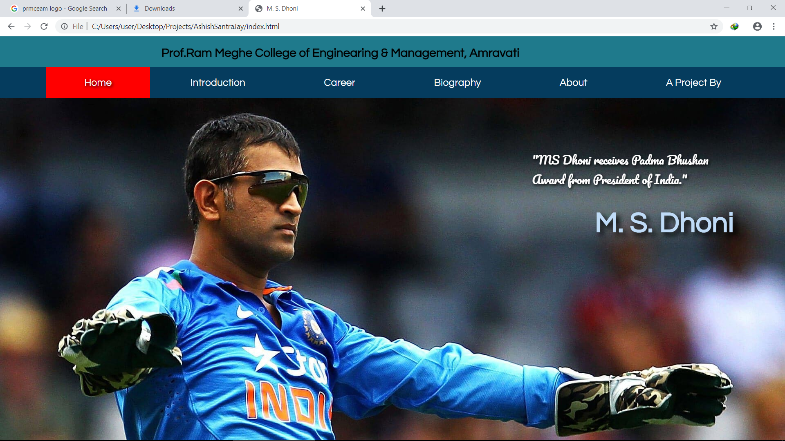

intro.html

<!DOCTYPE html>

<html>

<head>

<title>Introduction | M. S. Dhoni</title>

<link rel="stylesheet" type="text/css" href="style.css">

<link href="https://fonts.googleapis.com/css?family=Pacifico|Questrial" rel="stylesheet">

</head>

<body>

<header id="head">

<marquee><h2>Prof.Ram Meghe College of Enginearing & Management, Amravati&nbsp;&nbsp; &nbsp; &nbsp; &nbsp; &nbsp; &nbsp; &nbsp; &nbsp; &nbsp; &nbsp; &nbsp;&nbsp;&nbsp; &nbsp; &nbsp; &nbsp; &nbsp; &nbsp; &nbsp; &nbsp; &nbsp; &nbsp; &nbsp;&nbsp;&nbsp; &nbsp; &nbsp; &nbsp; &nbsp; &nbsp; &nbsp; &nbsp; &nbsp; &nbsp; &nbsp;&nbsp;&nbsp; &nbsp; &nbsp; &nbsp; &nbsp; &nbsp; &nbsp; &nbsp; &nbsp; &nbsp; &nbsp;&nbsp;&nbsp; &nbsp; &nbsp; &nbsp; &nbsp; &nbsp; &nbsp; &nbsp; &nbsp; &nbsp; &nbsp;&nbsp;&nbsp; &nbsp; &nbsp; &nbsp; &nbsp; &nbsp; &nbsp; &nbsp; &nbsp; &nbsp; &nbsp; Mini Project : M. S. Dhoni</h2></marquee>

intro.html

</header>

<nav class="container" id="navigation">

<ul>

<a href="index.html"><li>Home</li></a>

<a href="intro.html"><li class="current">Introduction</li></a>

<a href="career.html"><li>Career</li></a>

<a href="bio.html"><li>Biography</li></a>

<a href="about.html"><li>About</li></a>

<a href="info.html"><li>A Project By</li></a>

</ul>

</nav>

<div class="container" id="para">

<h1>M. S. Dhoni</h1>

<img src="smile.png" align="right" width="250px" height="200px" style="padding: 20px">

<p><font size="4"><font color="#000">&nbsp;&nbsp;&nbsp;&nbsp;&nbsp;&nbsp;Mahendra Singh Dhoni commonly known as MS Dhoni; born 7 July 1981) is an

intro.html

Indian international cricketer who captained the Indian national team in limited-overs formats from 2007 to 2016 and in Test cricket from 2008 to 2014. An attacking right-handed middle-order batsman and wicket-keeper, he is widely regarded as one of the greatest finishers in limited-overs cricket. He is also regarded as one of the best wicket-keepers in world cricket and is known to have very fast hands. He made his One Day International (ODI) debut in December 2004 against Bangladesh, and played his first Test a year later against Sri Lanka.</p>

<p>

Dhoni has been the recipient of many awards, including the ICC ODI Player of the Year award in 2008 and 2009 (the first player to win the award twice), the Rajiv Gandhi Khel Ratna award in 2007, the Padma Shri, India's fourth highest civilian honour, in 2009 and the Padma Bhushan, India's third highest civilian honour, in 2018. He was named as the captain of the ICC World Test XI in 2009, 2010 and 2013. He has also been selected a record 8 times in ICC World ODI XI teams, 5 times as captain. The Indian Territorial Army conferred the honorary rank of Lieutenant Colonel to Dhoni on 1 November 2011. He is the second Indian cricketer after Kapil Dev to receive this honour.</p>

intro.html

<p>&nbsp;&nbsp;&nbsp;&nbsp;&nbsp;&nbsp;Dhoni also holds numerous captaincy records such as the most wins by an Indian captain in Tests, ODIs and T20Is, and most back-to-back wins by an Indian captain in ODIs. He took over the ODI captaincy from Rahul Dravid in 2007 and led the team to its first-ever bilateral ODI series wins in Sri Lanka and New Zealand. Under his captaincy, India won the 2007 ICC World Twenty20, the CB Series of 2007–08, the 2010 Asia Cup, the 2011 ICC Cricket World Cup and the 2013 ICC Champions Trophy. In the final of the 2011 World Cup, Dhoni scored 91 not out off 79 balls handing India the victory for which he was awarded the Man of the Match. In June 2013, when India defeated England in the final of the Champions Trophy in England, Dhoni became the first captain to win all three ICC limited-overs trophies (World Cup, Champions Trophy and the World Twenty20). After taking up the Test captaincy in 2008, he led the team to series wins in New Zealand and West Indies, and the Border-Gavaskar Trophy in 2008, 2010 and 2013. In 2009, Dhoni also led the Indian team to number one position for the first time in the ICC Test rankings. In 2013, under his captaincy, India became the first team in more than 40 years to whitewash Australia in a Test series. In the Indian Premier League, he captained the Chennai Super Kings to victory at the 2010 and 2011 seasons, along with wins in the 2010 and 2014

intro.html

editions of Champions League Twenty20. He announced his retirement from Tests on 30 December 2014.</p>

<p>&nbsp;&nbsp;&nbsp;&nbsp;&nbsp;&nbsp;In 2011, Time magazine included Dhoni in its annual Time 100 list as one of the "Most Influential People in the World." In 2012, SportsPro rated Dhoni as the sixteenth most marketable athlete in the world. In June 2015, Forbes ranked Dhoni at 23rd in the list of highest paid athletes in the world, estimating his earnings at US$31 million. In 2016, a biopic M.S. Dhoni: The Untold Story was made about him.</p>

<p>&nbsp;&nbsp;&nbsp;&nbsp;&nbsp;&nbsp;Dhoni holds the post of Vice-President of India Cements Ltd., after resigning from Air India. India Cements is the owner of the IPL team Chennai Super Kings, and Dhoni has been its captain since the first IPL season. Dhoni is the co-owner of Indian Super League team Chennaiyin FC.</p>

<h2>Early life and background</h2>

<p><font size="4">&nbsp;&nbsp;&nbsp;&nbsp;&nbsp;&nbsp;Dhoni holds the post of Vice-President of India Cements Ltd., after resigning from Air India. IDhoni was born in Ranchi, Bihar (now in Jharkhand),

intro.html

and he identifies as a Hindu Rajput. His paternal village Lvali is in the Lamgarha block of the Almora District of Uttarakhand. Dhoni's parents moved from Uttarakhand to Ranchi, where his father Pan Singh worked in junior management positions in MECON. Dhoni has a sister Jayanti Gupta and a brother Narendra Singh Dhoni. Dhoni is a fan of Adam Gilchrist, and his childhood idols were cricket teammate Sachin Tendulkar, Bollywood actor Amitabh Bachchan and singer Lata Mangeshkar</p>

<p>&nbsp;&nbsp;&nbsp;&nbsp;&nbsp;&nbsp;Dhoni holds the post of Vice-President of India Cements Ltd., after resigning from Air India. IDhoni studied at DAV Jawahar Vidya Mandir, Shyamali, Ranchi, Jharkhand where he initially excelled in badminton and football and was selected at district and club level in these sports. Dhoni was a goalkeeper for his football team and was sent to play cricket for a local cricket club by his football coach. Though he had not played cricket, Dhoni impressed with his wicket-keeping skills and became the regular wicketkeeper at the Commando cricket club (1995–1998). Based on his performance at club cricket, he was picked for the 1997/98 season Vinoo Mankad Trophy Under-16 Championship and he performed well. Dhoni focused on cricket after his 10th standard. Dhoni was a Travelling Ticket Examiner (TTE)

intro.html

at Kharagpur railway station from 2001 to 2003, under South Eastern Railway in Midnapore (W), a district in West Bengal.[23][24][25] His colleagues remember him as a very honest, straightforward employee of the Indian Railways. But he also had a mischievous side to his personality. Once, while staying at the railway quarters, Dhoni and a couple of his friends covered themselves in white bedsheets and walked around in the complex late in the night. The night guards were fooled into believing that there were ghosts moving around in the complex. The story made big news on the next day.</p></br>

<h2>Captain of India</h2>

<p><font size="4">&nbsp;&nbsp;&nbsp;&nbsp;&nbsp;&nbsp;Dhoni was named the captain of Indian squad for the inaugural ICC World Twenty20 held in South Africa in September 2007. India were crowned champions as Dhoni led the team to victory against Pakistan in a thrilling contest. He went on to become the ODI captain of the Indian team for the seven-match ODI series against Australia in September 2007. He made his debut as full-time Test captain of India during the fourth and final Test against Australia at Nagpur in

intro.html

November 2008, replacing Anil Kumble who was injured in the third test and who then announced his retirement. Dhoni was vice-captain in this series up to that point. India eventually won that Test, thus clinching the series 2–0 and retained the Border-Gavaskar Trophy. Dhoni had previously captained India on a stand-in basis against South Africa and Australia, in 2008 and 2009 respectively.</p>

<img src="hit.jpg" align="left" width="350px" height="250px" style="padding: 20px">

<p>&nbsp;&nbsp;&nbsp;&nbsp;&nbsp;&nbsp;It was under his captaincy that India climbed to No. 1 in the ICC Test Rankings in December 2009. After that, he managed to lead India in a series-levelling world championship of Tests against the South Africans in February 2010. India also managed to draw the Test series 1–1 in South Africa later that year.</p>

<p>&nbsp;&nbsp;&nbsp;&nbsp;&nbsp;&nbsp;After winning the 2011 ICC Cricket World Cup final against Sri Lanka on 2 April 2011, with his match-winning knock of unbeaten 91, Tendulkar heaped praises on Dhoni, claiming him to be the best captain he has played under. Tendulkar mentioned that it was Dhoni's calm influence that

intro.html

was rubbing off on all his teammates and described Dhoni's handling of pressure as incredible.</p>

<p>&nbsp;&nbsp;&nbsp;&nbsp;&nbsp;&nbsp;Only eleven players have captained ten or more Tests playing as a wicket-keeper. Dhoni leads the table with 60 Tests as captain, 35 ahead of Mushfiqur Rahim in second place.</p>

<p>&nbsp;&nbsp;&nbsp;&nbsp;&nbsp;&nbsp;In March 2013, Dhoni became the most successful Indian Test captain when he eclipsed Sourav Ganguly's record of 21 victories from 49 Tests. Ganguly also said in an interview to a news channel that Dhoni is the all-time greatest captain of India and he has a great record to support this credential.</p>

<p>&nbsp;&nbsp;&nbsp;&nbsp;&nbsp;&nbsp;In August 2016, Dhoni was selected as captain for India's first tour to the United States, where India played two T20Is against the West Indies in Lauderhill, Florida. India lost the first match on 27 August 2016, during which Dhoni surpassed former Australian captain Ricky Ponting to become the most experienced captain in international cricket.</p>

intro.html

<p>&nbsp;&nbsp;&nbsp;&nbsp;&nbsp;&nbsp;Dhoni's final game as the Indian limited-overs captain was on 10 January 2017, in a warm-up game between England and India during the limited-overs leg of England's tour of India. Dhoni stated he will still fulfil his duties as the captain in various domestic teams.</p></br>

<h2>Indian Premier League</h2>

<p><font size="4">&nbsp;&nbsp;&nbsp;&nbsp;&nbsp;&nbsp;Dhoni was contracted by the Chennai Super Kings for 1.5 Million USD. This made him the most expensive player in the IPL for the first season auctions. Under his captaincy, Chennai Super Kings have won two Indian Premier League titles and the 2010 Champions League Twenty20. After the suspension of CSK for two years, he was bought by Rising Pune Supergiant for 1.9 Million USD in 2016, and was named captain. However, his team finished in 7th place. In 2018, Chennai Super Kings returned to IPL and Dhoni was again selected to lead the franchise.</p>

</div>

</body>

</html>



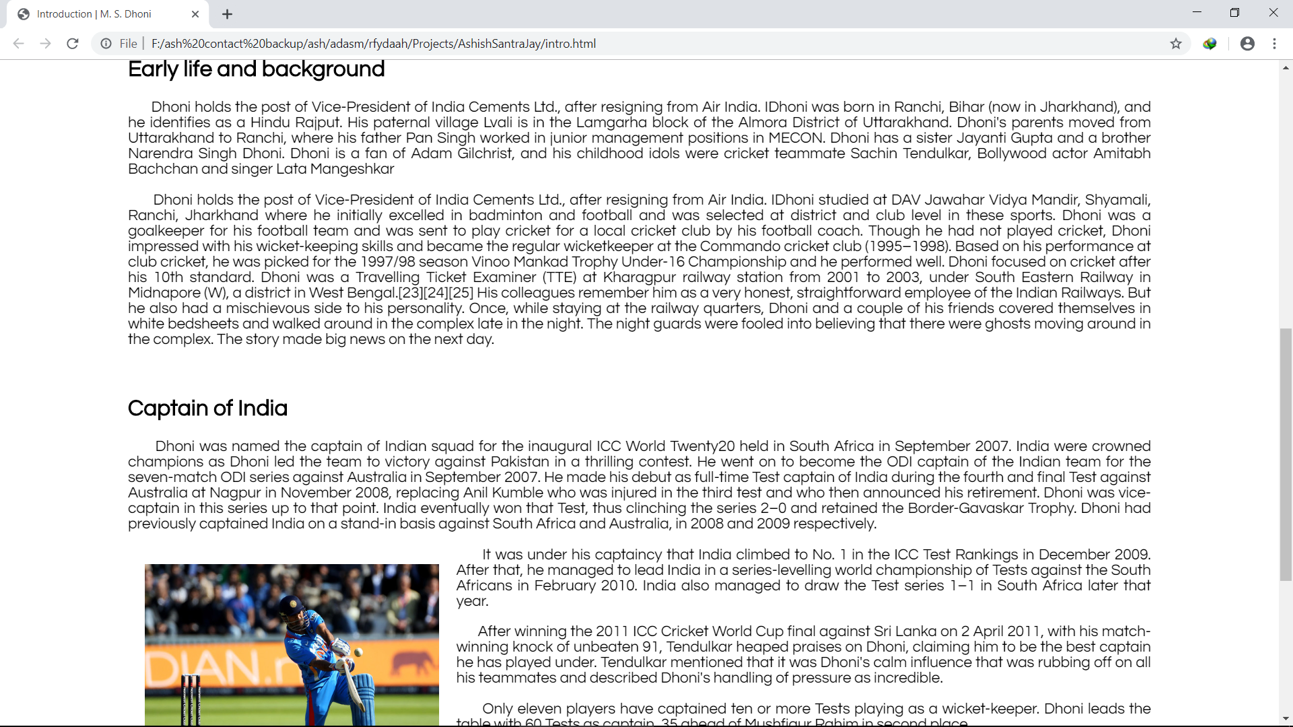

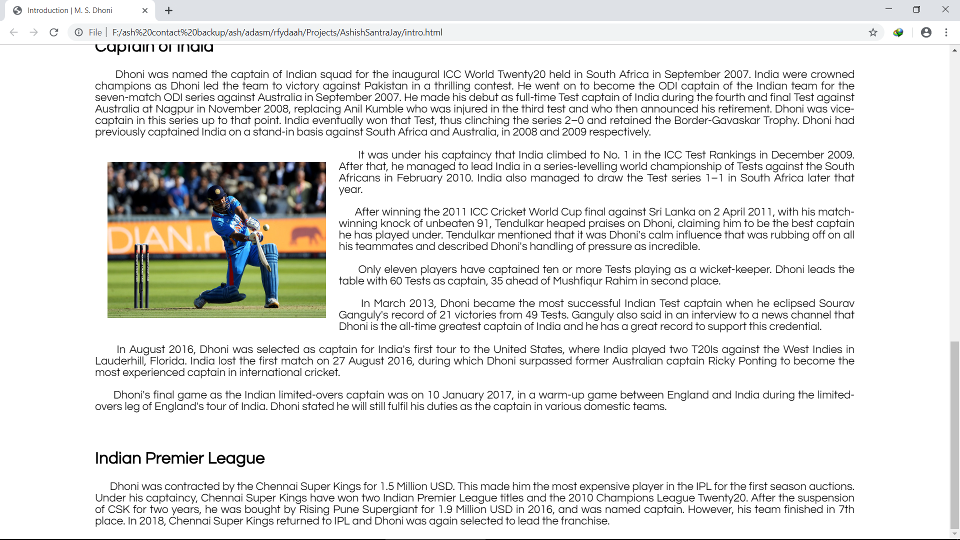

career.html

<!DOCTYPE html>

<html>

<head>

<title>Career | M. S. Dhoni</title>

<link rel="stylesheet" type="text/css" href="style.css">

<link href="https://fonts.googleapis.com/css?family=Pacifico|Questrial" rel="stylesheet">

</head>

<body>

<header id="head">

<marquee><h2>Prof.Ram Meghe College of Enginearing & Management, Amravati&nbsp;&nbsp; &nbsp; &nbsp; &nbsp; &nbsp; &nbsp; &nbsp; &nbsp; &nbsp; &nbsp; &nbsp;&nbsp;&nbsp; &nbsp; &nbsp; &nbsp; &nbsp; &nbsp; &nbsp; &nbsp; &nbsp; &nbsp; &nbsp;&nbsp;&nbsp; &nbsp; &nbsp; &nbsp; &nbsp; &nbsp; &nbsp; &nbsp; &nbsp; &nbsp; &nbsp;&nbsp;&nbsp; &nbsp; &nbsp; &nbsp; &nbsp; &nbsp; &nbsp; &nbsp; &nbsp; &nbsp; &nbsp;&nbsp;&nbsp; &nbsp; &nbsp; &nbsp; &nbsp; &nbsp; &nbsp; &nbsp; &nbsp; &nbsp; &nbsp;&nbsp;&nbsp; &nbsp; &nbsp; &nbsp; &nbsp; &nbsp; &nbsp; &nbsp; &nbsp; &nbsp; &nbsp; Mini Project : M. S. Dhoni</h2></marquee>

career.html

</header>

<nav id="navigation">

<ul>

<a href="index.html"><li>Home</li></a>

<a href="intro.html"><li>Introduction</li></a>

<a href="career.html"><li class="current">Career</li></a>

<a href="bio.html"><li>Biography</li></a>

<a href="about.html"><li>About</li></a>

<a href="info.html"><li>A Project By</li></a>

</ul>

</nav>

<div class="container" id="career">

<div style="margin-bottom: 100px; text-align: center;">

<img src="pressured.jpg" STYLE="WIDTH:450PX;HEIGHT:300PX;"><img src="p1.png" STYLE="WIDTH:450PX;HEIGHT:300PX;">

</br>

</div>

<h1>Career</h1>

career.html

<p>&nbsp; &nbsp; &nbsp; &nbsp; &nbsp;Dhoni began his career in 1998 by playing for Bihar U-19 team. He also played for East Zone U-19 team. In 1999-2000, he made a debut for Bihar in Ranji Trophy. His brilliant performances in the Deodhar Trophy, Duleep Trophy and India ‘A’ tour of Kenya, brought him to the notice of the national team selectors. He was then selected to play for the Indian Cricket team in 2004, where he made his ODI debut against Bangladesh in Chittagong.</p>

<p>&nbsp; &nbsp; &nbsp; &nbsp; &nbsp;Since then, Mahendra Singh Dhoni has come a long way in cricket. His sterling performances with the bat have rescued India from many a tight position. In his illustrious career, Dhoni has played 90 Tests scoring 4876 runs with his highest being 224 against Australia at Chennai in 2013. His amazing statistics behind the stumps include 256 catches and 38 stumpings.</p>

<p>&nbsp; &nbsp; &nbsp; &nbsp; &nbsp;In the ODI scenario, Dhoni has so far played 265 matches scoring 8620 runs, with his highest being a staggering 183 not-out against Sri Lanka, in Jaipur, 2005-06. His ODI wicket-keeping statistics include 246 catches and 85 stumpings. Dhoni made his ICC Cricket World Cup debut in 2007 and

career.html

played only three matches due to India’s early exit. India won the 2007 ICC World Twenty20 and 2011 ICC Cricket World Cup, among others, under his captainship.</p>

<p>&nbsp; &nbsp; &nbsp; &nbsp; &nbsp;He is also the captain of the Chennai Super Kings Team in the Indian Premier League (IPL). Under his captaincy, the team has won two IPL titles and also the Champions League Twenty20 in 2010.</p>

<table>

<h2><li>MS Dhoni Facts and information</li></h2>

<table border="2">

<tr><td>Full name</td>

<td>Mahendra Singh Dhoni</td></tr>

<tr><td>Born</td>

<td>7 July 1981 (age35), Ranchi, Bihar, India</td></tr>

career.html

<tr><td>Hometown</td>

<td>Almora, Uttarakhand</td></tr>

<tr><td>Nickname</td>

<td>Mahi, MS, MSD</td></tr>

<tr><td>Height</td>

<td>5 ft 9 in (1.75 m)</td></tr>

<tr><td>Batting style</td>

<td>Right hand batsman</td></tr>

<tr><td>Bowling style</td>

<td>Right arm medium</td></tr>

<tr><td>Role</td>

<td>Wicket-keeper, Indian Captain</td></tr>

<tr><td>National side</td>

career.html

<td>India</td></tr>

<tr><td>Major Teams</td>

<td>India, Asia XI, Bihar, Chennai Super Kings, Jharkhand, Rising Pune Supergiants</td></tr>

<tr><td>Test debut (cap 251)</td>

<td>2 December 2005 v Sri Lanka</td></tr>

<tr><td>Last Test</td>

<td>26 December 2014 v Australia</td></tr>

<tr><td>ODI debut (cap 158)</td>

<td>23 December 2004 v Bangladesh</td></tr>

<tr><td>Last ODI</td>

<td>15 June 2016 v Zimbabwe</td></tr>

<tr><td>ODI shirt no.</td>

<td>7</td></tr>

career.html

<tr><td>T20I debut (cap 2)</td>

<td>1 December 2006 v South Africa</td></tr>

<tr><td>Last T20</td>

<td>28 August 2016 v West Indies</td></tr>

</table></br>

</br>

<h2><li>Domestic Team Information</li></h2>

<table border="2">

<tr><th>Years</th>

<th>Team</th></tr>

<tr><td>1999/00-2003/04</td>

<td>Bihar</td></tr>

<tr><td>2004/05-present</td>

<td>Jharkhand</td></tr>

career.html

<tr><td>2008-2015</td>

<td>Chennai Super Kings</td></tr>

<tr><td>2016-present</td>

<td>Rising Pune Supergiants</td></tr></table></br>

<h2><li>Awards</li></h2>

&nbsp; &nbsp; &nbsp; &nbsp; &nbsp; He has also received the Man of the Series and the Man of the Match Awards on several occasions. He got his first Test Man of the Match Award in 2008 against Australia. It was the Sri Lanka in India ODI Series in 2005-06 where he received his first Man of the Series Award. He is also a recipient of the ICC Player of the year award for consecutive years in 2008 and 2009, The Rajiv Gandhi Khel Ratna award in 2007 and the Padma Shri award in 2009.

<h2><li>Retirement</li></h2>

career.html

&nbsp; &nbsp; &nbsp; &nbsp; &nbsp;Dhoni announced his retirement from International Test Cricket on 30 December 2014 following the drawn test between India and Australia in Melbourne. The reason that he cited behind his immediate retirement was the strain of playing cricket in all the formats of the game and to concentrate better on ODIs and T-20 matches. However, on 04 January 2017, he stepped down from the position of captain of the Indian ODI and T20I cricket teams, though reportedly he informed the board about his availability for selection for the upcoming series against England.

<h1>*Some of his Other Numerous Achievements are:</h1>

<ul >

<li>His 10 sixes in an innings are the sixth highest in ODI cricket.</li>

<li>He broke the record of Adam Gilchrist for the highest score made by a wicket keeper by scoring 183 runs.</li>

<li>He holds the record of maximum dismissals by an Indian wicketkeeper in an innings.</li>

<li>India reached the highest test score of 726-9, under his captaincy.</li>

career.html

<li>He is the only ODI captain to have played at number seven and scored a century. He did it in December 2012 while playing against Pakistan.</li>

<li>He is the first Indian wicketkeeper to reach 4000 tests runs.</li>

</ul>

</div>

</body>

</html>



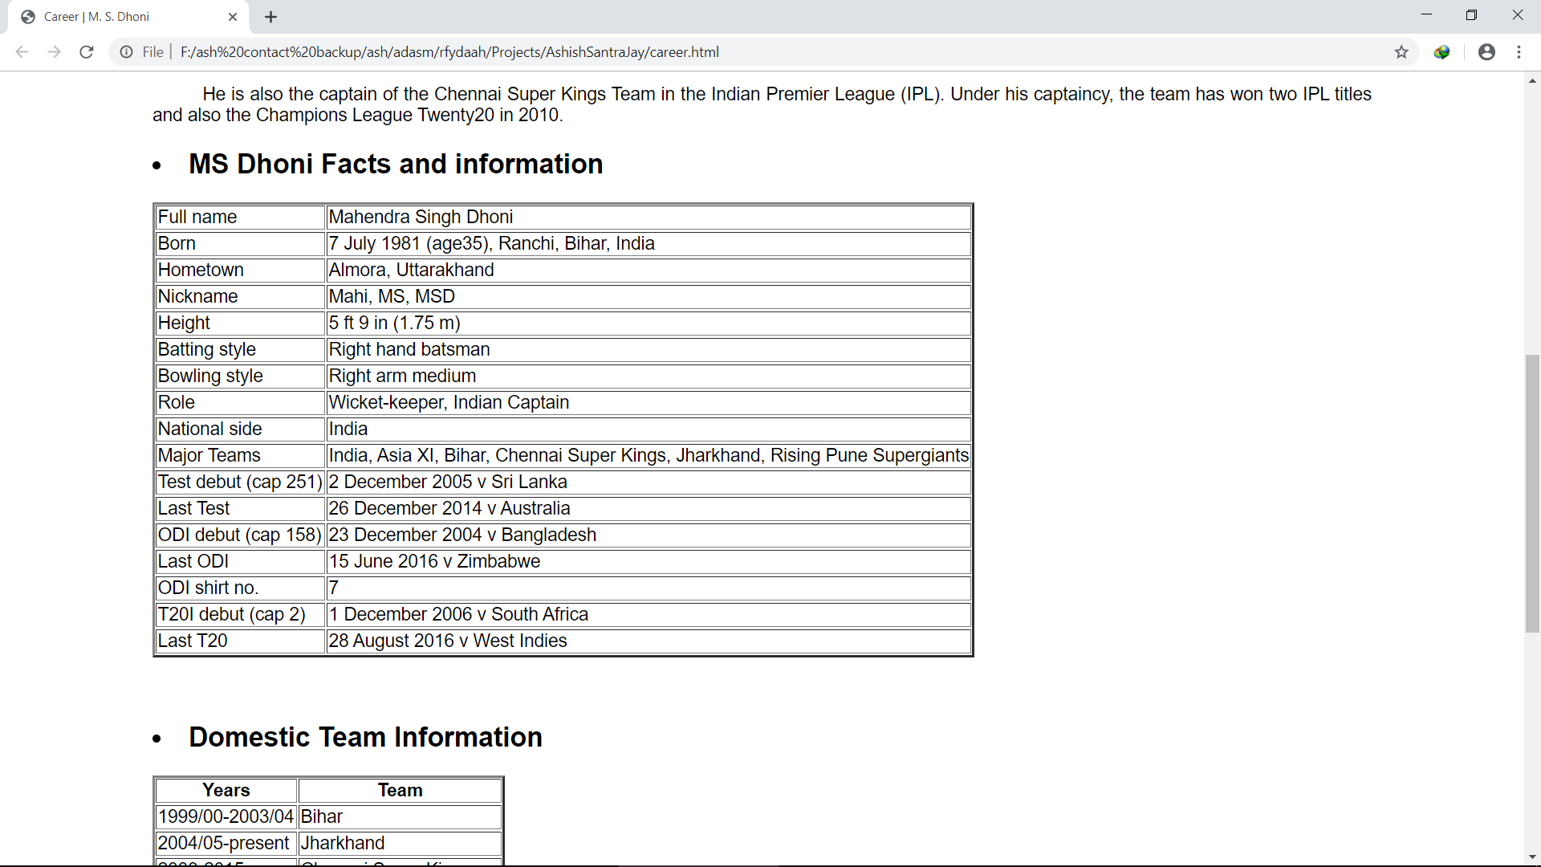

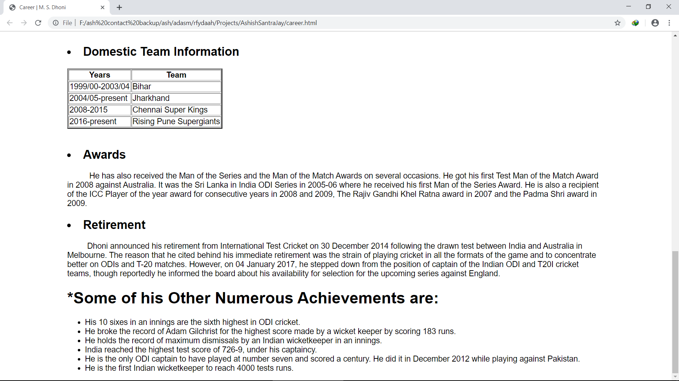

bio.html

<!DOCTYPE html>

<html>

<head>

<title>M. S. Dhoni</title>

<link rel="stylesheet" type="text/css" href="style.css">

<link href="https://fonts.googleapis.com/css?family=Pacifico|Questrial" rel="stylesheet">

</head>

<body>

<header id="head">

<marquee><h2>Prof.Ram Meghe College of Enginearing & Management, Amravati&nbsp;&nbsp; &nbsp; &nbsp; &nbsp; &nbsp; &nbsp; &nbsp; &nbsp; &nbsp; &nbsp; &nbsp;&nbsp;&nbsp; &nbsp; &nbsp; &nbsp; &nbsp; &nbsp; &nbsp; &nbsp; &nbsp; &nbsp; &nbsp;&nbsp;&nbsp; &nbsp; &nbsp; &nbsp; &nbsp; &nbsp; &nbsp; &nbsp; &nbsp; &nbsp; &nbsp;&nbsp;&nbsp; &nbsp; &nbsp; &nbsp; &nbsp; &nbsp; &nbsp; &nbsp; &nbsp; &nbsp; &nbsp;&nbsp;&nbsp; &nbsp; &nbsp; &nbsp; &nbsp; &nbsp; &nbsp; &nbsp; &nbsp; &nbsp; &nbsp;&nbsp;&nbsp; &nbsp; &nbsp; &nbsp; &nbsp; &nbsp; &nbsp; &nbsp; &nbsp; &nbsp; &nbsp; Mini Project : M. S. Dhoni</h2></marquee>

bio.html

</header>

<nav id="navigation">

<ul>

<a href="index.html"><li>Home</li></a>

<a href="intro.html"><li>Introduction</li></a>

<a href="career.html"><li>Career</li></a>

<a href="bio.html"><li class="current">Biography</li></a>

<a href="about.html"><li>About</li></a>

<a href="info.html"><li>A Project By</li></a>

</ul>

</nav>

<div class="container" id="bio">

<h1>Mahendra Singh Dhoni Biography</h1>

<p>&nbsp;&nbsp; &nbsp; &nbsp; &nbsp; &nbsp; &nbsp; &nbsp; &nbsp; &nbsp; &nbsp; &nbsp;Mahendra Singh Dhoni or M S Dhoni is an Indian cricketer and former captain of the Indian national cricket team; however, he captains the team only in limited-overs format. Nicknamed ‘Mahi’, this spectacular and promising wicket-keeper/batsman filled in the much-awaited void in Team India’s lineup, and since then has proved his worth. With his swashbuckling

bio.html

attitude and unique hairstyle, Mahendra Singh Dhoni has become a popular cricket and marketing icon in India. He is an aggressive right-handed batsman and wicket-keeper.</p>

<img src="smile.png" width="250" height="180" align="right" style="padding: 10px">

<h2><li>Background</li></h2>

<p> &nbsp;&nbsp; &nbsp; &nbsp; &nbsp; &nbsp; &nbsp;Dhoni was born on 7 July 1981 in Ranchi, Jharkhand to Pan Singh and Devaki Devi. He has a sister Jayanti and a brother Narendra Singh Dhoni. Originally his family belonged to Almora district of Uttarakhand. He had studied at the DAV Jawahar Vidya Mandir School in Ranchi, Jharkhand. Initially, during his school days, he used to play badminton and football and in fact was the goalkeeper of his football team. Once, he was sent by his football coach to play cricket for a local cricket club. It was in this match that he impressed everyone with his wicket-keeping skills which resulted in getting him a regular post of the wicketkeeper at the Commando Cricket Club. From 2001 to 2003, he worked as a Train Ticket Examiner (TTE) at the Kharagpur Railway Station under South Eastern Railway in Midnapore (W).</p>

bio.html

<br>

<h2><li>Personal Life </li></h2>

<img src="sakshi.jpg" width="250" height="180" align="left" style="padding: 10px;">

<p>&nbsp; &nbsp; &nbsp; &nbsp; &nbsp; &nbsp;Dhoni got married to Sakshi Singh Rawat on 4 July 2010. The couple has a daughter, Ziva who was born on 6 February 2015.</p>

<p>&nbsp; &nbsp; &nbsp; &nbsp; &nbsp; &nbsp;Dhoni married Sakshi Singh Rawat, his schoolmate in DAV Jawahar Vidya Mandir, Shyamali. a native of Dehradun, Uttarakhand, on 4 July 2010. At the time of their marriage, she was studying hotel management and was working as a trainee at the Taj Bengal, Kolkata. After the retirement of Sakshi's father from his tea growing business, their family shifted to their native place, Dehradun.</p>

<p>&nbsp; &nbsp; &nbsp; &nbsp; &nbsp; &nbsp;The wedding took place one day after the couple got engaged. According to Bollywood actress Bipasha Basu, a close friend of Dhoni, the wedding was planned for months and was not a spur of the moment decision. Dhoni became a father on 6 February 2015 to a baby girl named Ziva.</p>

bio.html

<div id="members">

<h2><b><li>Family Members</li></b></h2>

<img src="family.png" width="300" height="220" align="center">

<table>

<tr>

<th>Relation</th>

<th>Name</th>

</tr>

<tr>

<td>Father</td>

<td>&nbsp; &nbsp; &nbsp; &nbsp;Pan Shingh</td>

</tr>

<tr>

<td>Mother</td>

<td>&nbsp; &nbsp; &nbsp; &nbsp;Devki Devi</td>

</tr>

<tr>

<td>Wife</td>

<td>&nbsp; &nbsp; &nbsp; &nbsp;Sakshi Singh Rawat</td>

</tr>

<tr>

bio.html

<td>Brother</td>

<td>&nbsp; &nbsp; &nbsp; &nbsp;Narendra Singh Dhoni</td>

</tr>

<tr>

<td>Sister</td>

<td>&nbsp; &nbsp; &nbsp; &nbsp;Jayanti Gupta</td>

</tr>

<tr>

<td>Children</td>

<td>&nbsp; &nbsp; &nbsp; &nbsp;Ziva Dhoni</td>

</tr>

</table>

</div>

</div>

</body>

</html>



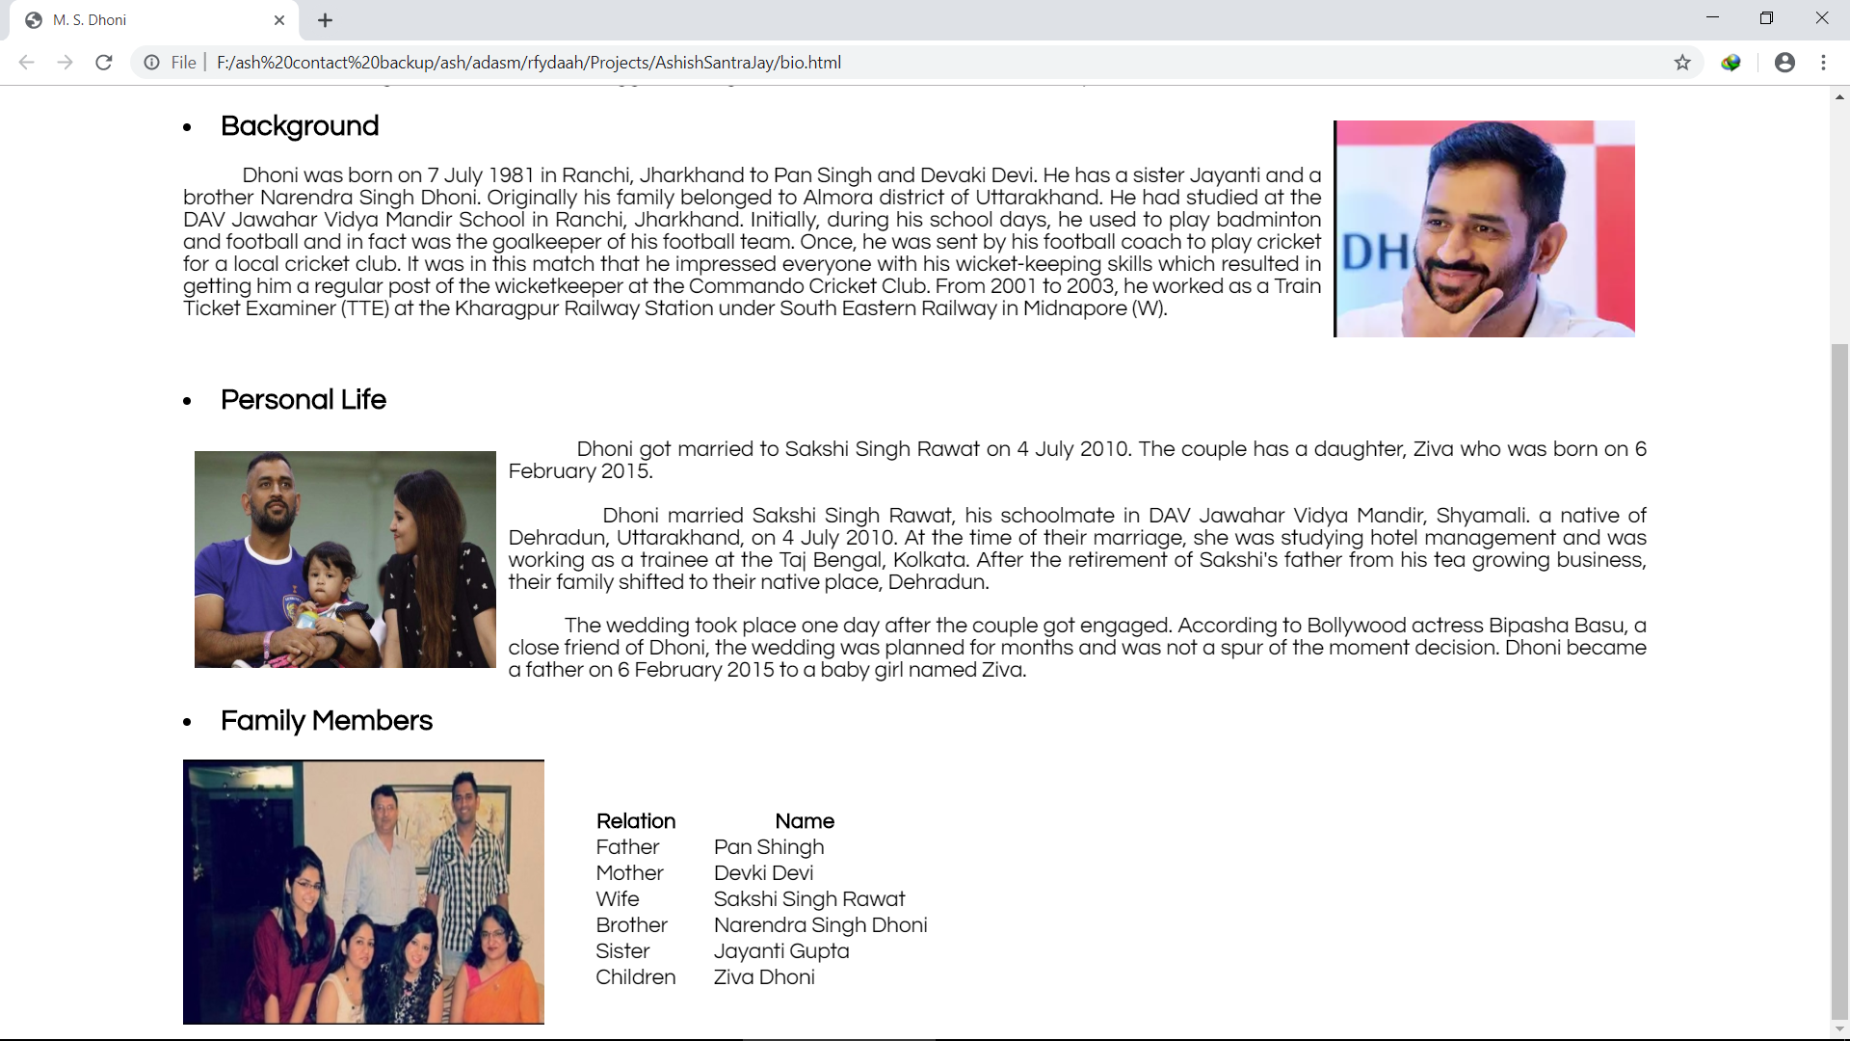

about.html

<!DOCTYPE html>

<html>

<head>

<title>M. S. Dhoni</title>

<link rel="stylesheet" type="text/css" href="style.css">

<link href="https://fonts.googleapis.com/css?family=Pacifico|Questrial" rel="stylesheet">

</head>

<body>

<header id="head">

<marquee><h2>Prof.Ram Meghe College of Enginearing & Management, Amravati&nbsp;&nbsp; &nbsp; &nbsp; &nbsp; &nbsp; &nbsp; &nbsp; &nbsp; &nbsp; &nbsp; &nbsp;&nbsp;&nbsp; &nbsp; &nbsp; &nbsp; &nbsp; &nbsp; &nbsp; &nbsp; &nbsp; &nbsp; &nbsp;&nbsp;&nbsp; &nbsp; &nbsp; &nbsp; &nbsp; &nbsp; &nbsp; &nbsp; &nbsp; &nbsp; &nbsp;&nbsp;&nbsp; &nbsp; &nbsp; &nbsp; &nbsp; &nbsp; &nbsp; &nbsp; &nbsp; &nbsp; &nbsp;&nbsp;&nbsp; &nbsp; &nbsp; &nbsp; &nbsp; &nbsp; &nbsp; &nbsp; &nbsp; &nbsp; &nbsp;&nbsp;&nbsp; &nbsp; &nbsp; &nbsp; &nbsp; &nbsp; &nbsp; &nbsp; &nbsp; &nbsp; &nbsp; Mini Project : M. S. Dhoni</h2></marquee>

about.html

</header>

<nav id="navigation">

<ul>

<a href="index.html"><li>Home</li></a>

<a href="intro.html"><li>Introduction</li></a>

<a href="career.html"><li>Career</li></a>

<a href="bio.html"><li>Biography</li></a>

<a href="about.html"><li class="current">About</li></a>

<a href="info.html"><li>A Project By</li></a>

</ul>

</nav>

<div class="container" id="about">

<h1>About</h1>

<p>&nbsp;&nbsp;&nbsp;&nbsp;&nbsp;&nbsp;The project name is "Unbeatable M S Dhoni". It is a mini project based on html. We know that HTML is a markup language used to developed web pages, so using this language we created our mini project. The actual designing of the web pages are done at good level. In this project we have used various types of tags which are used in HTML. The tags are useful

about.html

content of web pages and so web pages are fully depend on this tags.</p>

<p>&nbsp;&nbsp;&nbsp;&nbsp;&nbsp;&nbsp;This mini project gives us short Idea about M S Dhoni and his journey in cricket .Introduction,Career,Biography and About are four prime component of this project. In Introduction we have mentioned the short life of M S Dhoni ,Background,contribution of Dhoni for India, and his life in IPL. The next section is about his Career.In this part we have mentioned the Carrer of M S Dhoni. The sub section which we have given here is "Facts and information" and in which we have write the Information about M S Dhoni. There are some sub parts are also included i,e Awards,Retirements. After this section the most Impressive and Influential part is 'Biography'. In which we have mentioned the background, personal life and family members of M S Dhoni. This are most prominant parts of this mini project. At last we use the 'About' component.</p>

<p>&nbsp;&nbsp;&nbsp;&nbsp;&nbsp;&nbsp;In this way we have tried our best to provide the Information about M S Dhoni and it's blissful life. </p>

</div>

</body>

</html>



info.html

<!DOCTYPE html>

<html>

<head>

<title>M. S. Dhoni</title>

<link rel="stylesheet" type="text/css" href="style.css">

<link href="https://fonts.googleapis.com/css?family=Pacifico|Questrial" rel="stylesheet">

</head>

<body>

<header id="head">

<marquee><h2>Prof.Ram Meghe College of Enginearing & Management, Amravati&nbsp;&nbsp; &nbsp; &nbsp; &nbsp; &nbsp; &nbsp; &nbsp; &nbsp; &nbsp; &nbsp; &nbsp;&nbsp;&nbsp; &nbsp; &nbsp; &nbsp; &nbsp; &nbsp; &nbsp; &nbsp; &nbsp; &nbsp; &nbsp;&nbsp;&nbsp; &nbsp; &nbsp; &nbsp; &nbsp; &nbsp; &nbsp; &nbsp; &nbsp; &nbsp; &nbsp;&nbsp;&nbsp; &nbsp; &nbsp; &nbsp; &nbsp; &nbsp; &nbsp; &nbsp; &nbsp; &nbsp; &nbsp;&nbsp;&nbsp; &nbsp; &nbsp; &nbsp; &nbsp; &nbsp; &nbsp; &nbsp; &nbsp; &nbsp; &nbsp;&nbsp;&nbsp; &nbsp; &nbsp; &nbsp; &nbsp; &nbsp; &nbsp; &nbsp; &nbsp; &nbsp; &nbsp; Mini Project : M. S. Dhoni</h2></marquee>

info.html

</header>

<nav id="navigation">

<ul>

<a href="index.html"><li>Home</li></a>

<a href="intro.html"><li>Introduction</li></a>

<a href="career.html"><li>Career</li></a>

<a href="bio.html"><li>Biography</li></a>

<a href="about.html"><li>About</li></a>

<a href="info.html"><li class="current">A Project By</li></a>

</ul>

</nav>

<section id="details">

<div class="container">

<h1>Project Team</h1>

<h2><li>Team Members</li></h2>

</div>

<div class="container">

<div class="name">

<h3>Ashish S. There</h3>

<p>CSE 2<sup>nd</sup> Year (Section A)<br>

Roll No.:- 47

info.html

</p>

</div>

<div class="name">

<h3>Prajwal D. Mahajan</h3>

<p>CSE 2<sup>nd</sup> Year (Section A)<br>

Roll No.:- 31

</p>

</div>

<div class="name">

<h3>Jay A. Wankhade</h3>

<p>CSE 2<sup>nd</sup> Year (Section A)<br>

Roll No.:- 53

</p>

</div>

</div>

</section>

</body>

</html>

